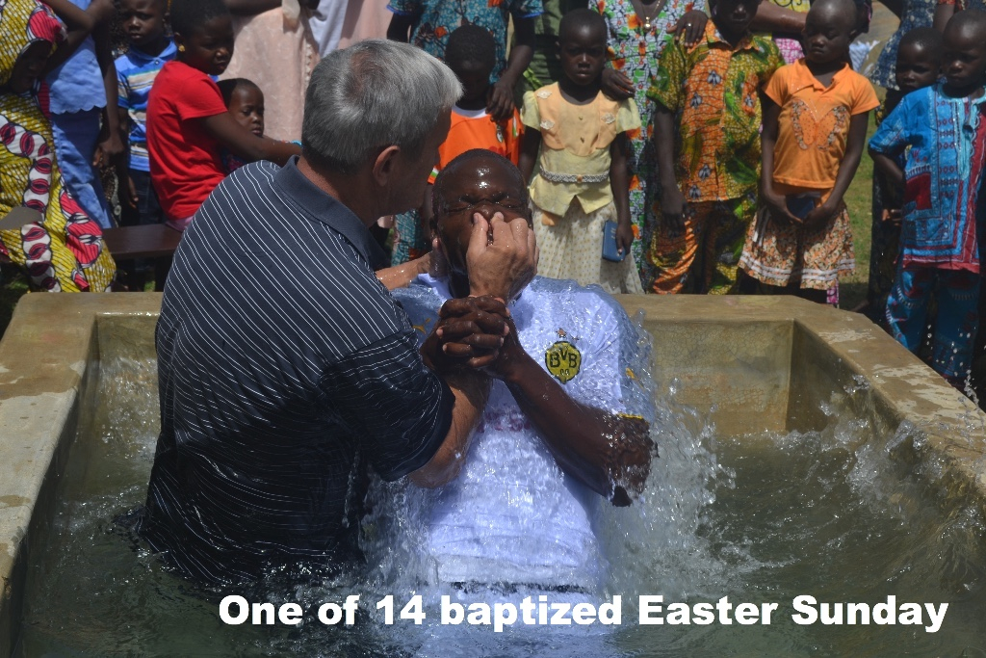

June 2016

Dear Praying Friends,

Mr. Makie, who was recently baptized at the Lome II church, had been on a journey for many years to find the truth. As a young man he attended the Catholic Church, but when visited by the Jehovah Witnesses began going to their worship services. He still had not found the truth, so when his new wife persuaded him to leave all of that behind and follow the old fetish ways, he readily consented. Year followed year, and he still could not find peace. When his wife became ill, finally to the point of death, she asked him to go find a pastor to pray with her. God in his grace let Mr. Makie to Pastor Pali who had been led to the Lord in our 2nd church and subsequently became the pastor. He contacted Pastor Philip who lived closer to the family and this dear brother was able to lead the lady to the Lord just before her death. She spoke clearly to her husband and 5 children, telling them she had been wrong in following the fetish worship and for them to abandon it. I took her body to the village to be buried, and we were able to minister to the family at that difficult time. God continued working, and in time, Mr. Makie and 4 of his children came to Christ. We are still praying for the 19 year old who has not yet made this decision. Pastor Henoc abruptly left the Lassa church in January, one of our more struggling congregations. We ask that you pray that God would give me wisdom, strength, and guidance to lead, and that the devil will not gain victory during this difficult time.

Three years ago we introduced you to Esther, a young girl we had taken into our home. She is in her last year of high school and will take a final exam soon. Pressure is intense as a student must pass this single test to successfully finish high school. Esther is very anxious about this, even though we have just asked that she do her best. Please pray for her that she will have good health and clarity of mind.

Our Tchaloude church recently lost 2 young men in one weekend, one to a motorcycle accident, and another to a disease. These were faithful members and their loss has been deeply felt in the small congregation. Please pray for the leader, Abalo, and the church family as well, that they would be able to move past this.

We have had frequent interruption of electricity and internet service in the last few months. Because of this, communication with the states has been very difficult.

Most of us have heard the old adage to not let dust collect on your Bible before you pick it up again. Because of the extremely heavy harmattan (dirt in the air from the Sahara desert blowing down to us) that we have dealt with for the last 3 months, dust settles heavily on our Bibles in a mere 30 minutes! Only in West Africa!
Your missionaries in Togo,

The Aldermans

