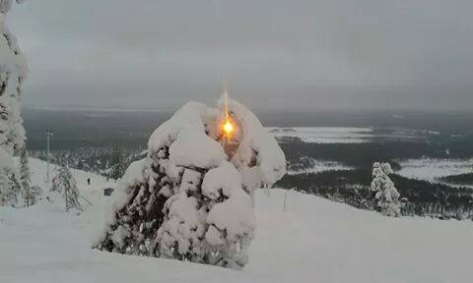

November 27, 2015
Dear Praying Supporters,
In his hymn, “The Light of the World is Jesus,” Philip Bliss wrote the following words: “The whole world was lost in the darkness of sin, the light of the world is Jesus! Like sunshine at noonday, His glory shone in. The light of the world of Jesus!” Merry Christmas to all of you as we celebrate the birth of the “Light of the World,” the Lord Jesus Christ.
It has been a real blessing for us to be able to assist our Reseeding America missionary church planters in 2015. It is exciting to see how God uses surrendered couples and families who have a heart for the lost. Our Lord has placed them in different parts of our country with a burden to reach people with the Gospel. We are also grateful for the new couples God gave this ministry in 2015 and how they have answered God’s call to go to America.
This past year found us involved in more mission conferences and mission meetings than in previous years. Again, we are thankful to our Lord for His guidance in these meetings and for the Lord’s protection as we traveled. It was exciting and a real privilege to meet many new pastors and congregations along the way. Praise God for the churches that experienced an increase in their faith promise giving to worldwide evangelization!
The spring field conferences for our USA church planters and their families were held in April and May in Tennessee and Arizona. The East Coast Conference and West Coast Conference were both well attended by our church planters. It was a time of encouragement, fellowship, fun, and fresh challenges for all of our people.
Our summer and fall projects included a large Scripture distribution at Scottsboro, Alabama and a new church start at Eastman Georgia. We finished up the fall with the restart of Lighthouse Baptist Church at Vacaville, California near the Bay area. More details on the Vacaville project will be coming out in the next issue of the Reseeding America Magazine.
Finally, we are thankful for your faithful prayer and financial support over this past year. May you have a Merry Christmas and a Happy New Year!! Much love to you, dear friends! God bless you!
Bob and Jennifer Larson
PS: Praise the Lord for our family, 11 grandchildren AND a new grandbaby coming in 2016!!
Mission Agency: Baptist International Missions, Inc. Sending Church: Friendship Baptist Church · Highland, AR
· Mike Stanley, Pastor · Home Address: [home-address]

