 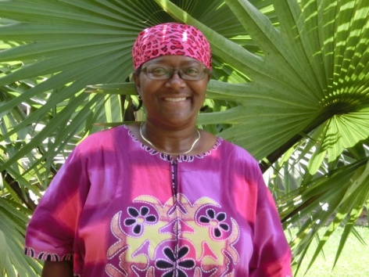 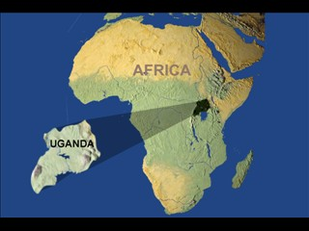

MAY-JUN 16

DEAR FELLOW SUPPORTERS:

**NURSING STUDENTS FROM TUBOR**. I got the opportunity to speak to ten students and this was during a Monday morning I would have been teaching at St. Pius. These students are a part of St. Pius, but located in Tubor. I have been meaning to visit there for some time. It was great to talk with students and staff that I have not seen before about Jesus. After the morning session, they promised that they would come to visit me at church on Wednesday night. They kept their promise! They were only in the area for 2 weeks; long enough for practicals and written exams. *Pray that I will be able to visit them sometime this year*.

**ORPHANS AND STAFF STUDENTS AIMING HIGH**…These are SOAPS’s first group of S5 LEVEL (11th grade*) students. Pray that they not only aim high physically in education, but more important to aim higher at keeping Jesus first in their lives as they prepare to follow His leading in the future.*

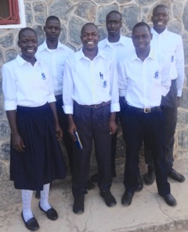**From front left to right: Betty (o), Jacob (o), Tony (s)**

**From back left to right: Moses (s), Musa (o), and Antoine (s)**

**UGANDA’S MANNA FROM HEAVEN…**In which I am very reluctant to try as of

yet…White Ants (termites). When the rains come these insects come out of the ground in groves late in the night. They are attracted to the lights like a moth. Below the sellers outside the market place have taken their wings off, dried, and fried the ants.

YUM, YUM!

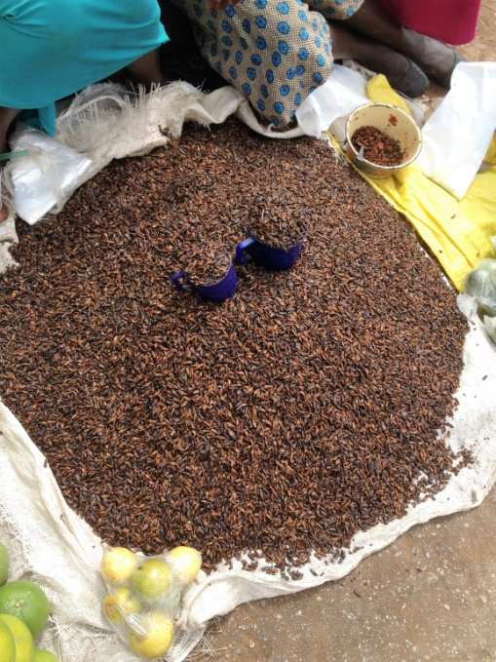

**A SPECIAL PERSON THAT BRINGS A SMILE TO THE FACE….**Mrs. Rose, 70 or more years old, has been coming on Sunday consecutively for 8 weeks. The 9th week she was sick. She lives near the church. She professed to be Catholic, yet she considers Soroti Independent Baptist Church to be “her” church. Mrs. Rose can barely walk. She uses a walker to get around very, very, very slowly and cannot hear very well either. She had a disease in which the doctors did not even think she would get out of bed let alone walk again. When she invited her daughter to come with her, she told us her mother’s story. When I teach in Sunday School, I have to speak very loud and be at the back of the class close to her. Mrs. Rose knows and speaks English very well. She brings her Bible to church and she is always on time. She does not like to be late. When we went to visit her she told me she reads her Bible every day. In her condition most people (Christians) would not dare to come to church, but not Mrs. Rose. *Pray for her health and maybe a hearing aide*.

**REALLY…DO PEOPLE BELIEVE THIS…**There are such posters around Soroti all the time. Someone put one on a big tree of mine and I remove it. It was not this Dr. but another one. Whoever this person is, he is so assured that he has written: “PAY AFTER RESULTS”… Do they cure you? Or how long before the symptoms return? *I guess I could call the cell at the bottom.* Would you say this poster is in the same category as palm readers, wigi boards, people who read crystal balls, etc. that are in the states.

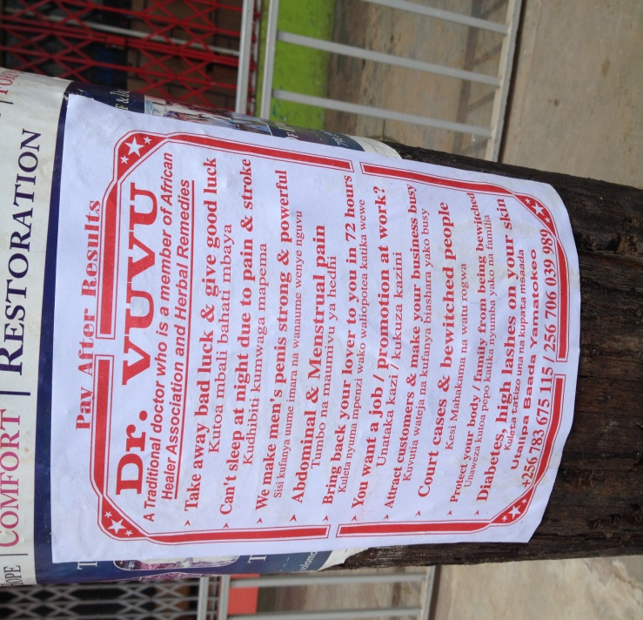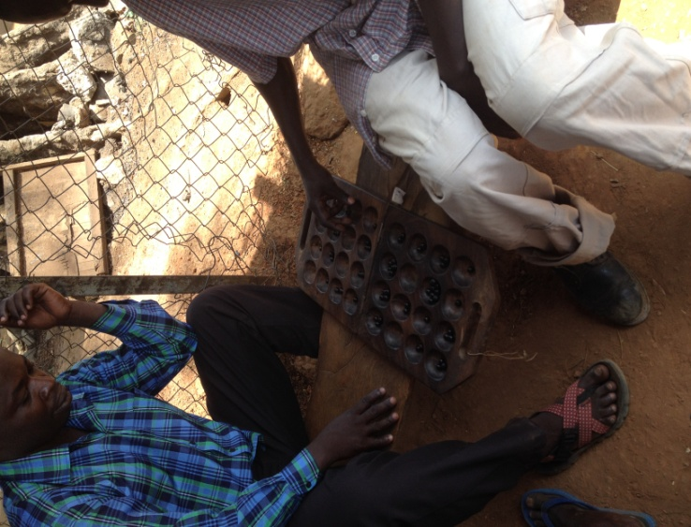

**WHAT IS THIS GAME?... (pix above and to the right)** In my walking around town, I often see men not women playing this game. I stand and watch them play it. I ask questions and people answer my questions; however, I still don’t understand the object, except to get all the beads on your side of the board. I thought chess was hard; this game does not have anything on it! It is a fast pace game. All I do is get frustrated, just watching it. There are 68 beads and 24 holes. Our children at the orphanage have dug the holes in the ground and play the game. The seeds come from a particular type of fruit. These boards are made locally. I have to do more investigation. The young man to the left in the blue shirt is Joseph. Joseph is a Pastor and welder. I definitely will inquire more about this game from him. It was on a Monday returning from St. Pius when I saw Joseph playing at this boda boda stand. He was winning too. When I know how such games are played I can use it as a tool to talk to people about Jesus, just like learning the game of Futbol (soccer).

**THINGS THAT PEOPLE SAY TO ME…THAT HELPS ME TO REMEMBER WHY I AM IN UGANDA..**.”**WELL DONE**!”: people just use this as a greeting. I do nothing to have them say this to me. I just be walking and someone would say this to me. This reminds me that one day when I see Jesus I so much look forward to hearing Him say to me…”Well done thou good and faithful servant…” Another greeting: **“WHAT’S GOOD TODAY? Or WHAT’S THE GOOD WORD FOR TODAY?”** This question just opens the door for a witness for Christ. And, I definitely walk through it! Another one: **“HEY, GIVE ME ONE OF THEOSE PAPERS!”** I try to always have tracts on me. I normally carry a backpack in which are full of tracts. I would hate to be out when someone says this to me.