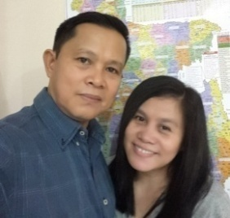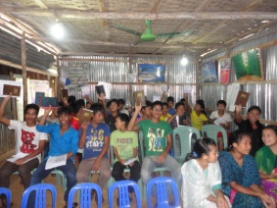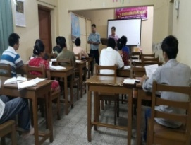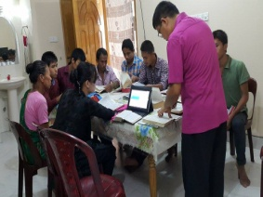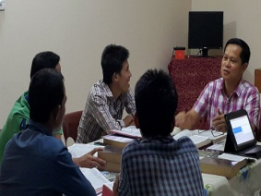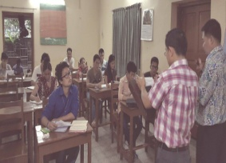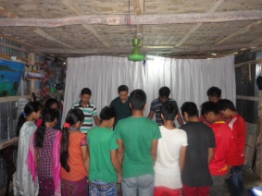

**Dr. Rodney Kelley**

West Jacksonville Baptist Church

Jacksonville Fl USA

Please continue to uphold us in your prayers with the following requests.

1. God’s provision for the processing of new visa.

a. US$ 1,100 for the remaining balance for the processing of permit to get visa.

b. US$ 1,200 for five (5) year visa.

2. Government's approval of our application for five year visa.

3. More open doors for the gospel and more souls to be saved.

4. Good health, specially for my wife ( Annie)

5. Spiritual growth of new believers .

6. God's protection against terrorist who are targeting foreigners.

7. God's guidance in leading us to another place of opportunities to preach the gospel.

8. More churches to partner with us in our ministry.

Guest teacher at a (DTS) Discipleship Training Seminar in partnership with local pastor in Chittagong.

December 01,2015

Dear Pastor and Church,

Greetings in the precious name of our Lord and Saviour Jesus Christ.

We praise God for His provision upon us through your faithful and consistent support in our ministry here. On October, we were able to pay a partial amount for the processing of a new set of five year visa application. Our visa will expire on the first week of March 2016, we hope and pray that before it expires the permission will be released otherwise we will be forced to temporarily leave the country.

Just recently, our ministry suffers a lot of trials since the government imposed a policy of not allowing foreigners specially missionaries to enter the villages in the Hill Tracts where our extension ministries are located. I was denied several times to get a permit to enter for security reason due to the recent killing of foreigners, especially those who are working in the religious sectors particularly Christians. The said killings were done by some religious Muslim extremist group. Even local Christian leaders were targeted and some received death threats already. But despite constant fear through hearing news of atrocities, yet we continue to carry on the task believing that the Lord our God will protect us.

Some local Pastors invited me to teach on their discipleship training seminars and it was a great privileged to be a blessing. On the month of November I made a survey in the City of Cox's Bazar for a potential opening of another ministry. Trusting God's leading on this.

Once again thank you for your prayers and support. May the Lord our God continue to bless and use you more for His glory and honour.

In Christ’s service,

German and Annie Ponce

Bible study and discipleship at my rented house in Chittagong

Distribution of English Bible and prayer of dedication during our worship service with the students at the hostel in Bandarban.

**MISSION UPDATE**

**AND PRAYER LETTER**

**OCT. & NOV. 2015**

PRAYER REQUESTS

I acknowledge your support received on the month of October USD 80 and November USD 40.

**House Address: Unit 5-B, House #10, Lane # 1, Road # 3, K-Block, Halishahar H/E, Chittagong City, Bangladesh 4216**

**Misnry German & Annie Ponce  *Mobile: Roaming* Smart #: +639205677588 */* Bangla #-+8801683973428 *EmailAdd:* ponce_german@yahoo.com**

“ …not seeking ***mine own******profit***, but the ***profit*** ***of many***,

that they may ***be saved.***” 1Cor. 10:33b