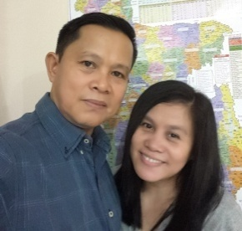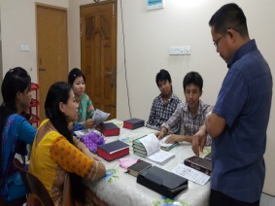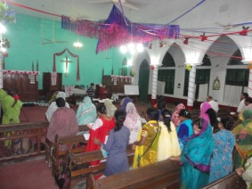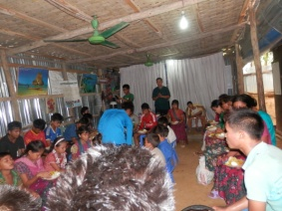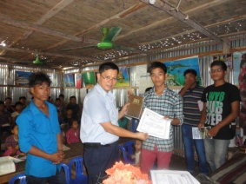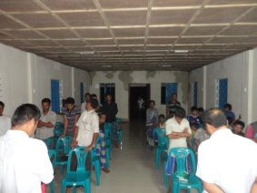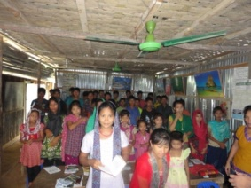 

**MISSION UPDATE**

**AND PRAYER LETTER**

**AUGUST & SEPTEMBER 2015**

Pastor Rodney Kelly

WJBC Jacksonville

Fl. USA

Bible study and discipleship at my rented house in Chittagong

Preaching at a revival meeting in the province of Borisal

Distributing English Bible and Certificate of baptism to the newly baptized believers in Bandarban.

Feeding program with the students at the hostel in Bandarban

Bible study and worship service with the students at the hostel in Bandarban

PRAYER REQUESTS

Dear Pastor and Church,

Greetings! To God be the glory.

We thank God for the answered prayers, and thank you also for your unceasing prayers for us. After the trials of faith, the Lord opens unto us opportunities to share the gospel to the lost souls. On August, I had the privilege to preach to a group of Buddhist people from the Marma tribe in the village of Ranerhat, Rangamati, where more than ten souls received the Lord Jesus Christ as their saviour. God gave me another opportunity to be one of the speakers in the province of Borisal on their Revival Meeting.

The government imposed a strict law forbidding foreigners specially missionaries to enter into the tribal villages of Chittagong Hill Tracts, but praise God, I was able to enter again into the village of Bandarban as a tourist by paying an extra amount of money to the authorities to get a permit just to continue on feeding the Word of God to our brethren. I was able to conduct our worship service, Bible study and discipleship; along with is the distribution of Bibles and other reading materials. Thus, I was able to conduct feeding program for our students at the hostel. Thank God for His provision.

Hence, our ministry in Chittagong is continuing with new visitors coming brought by our disciples in our rented house weekly. They are of Hindu and Buddhist background; praise God they heard the gospel for the first time.

Thank you once again for your partnership in preaching the gospel here in Bangladesh. May God continue to use you more for his glory and honour.

In Christ’s service,

German and Annie Ponce

Please continue to uphold us in your prayers with the following requests.

1. God’s provision for the processing of new visa. ( US$ 2,700)

a. US$ 1,500 for the processing of permit to get visa.

b. US$ 1,200 for five (5) year visa.

2. God’s leading and wisdom in partnering with other local pastors

3. More open doors for the gospel and more souls to be saved.

4. God’s enablement as we continue the work

4. Good health, specially for my wife ( Annie) for another set of check up

5. Spiritual growth of new believers .

6. God's protection against terrorist who were targeting foreigners.

They accept the Lord Jesus Christ as their savior during our evangelistic meeting in Rangamati.

I acknowledge the receipt of your support on the month of August the amount of USD 40.00.

**House Address: Unit 5-B, House #10, Lane # 1, Road # 3, K-Block, Halishahar H/E, Chittagong City, Bangladesh 4216**

**Misnry German & Annie Ponce  *Mobile: Roaming* Smart #: +639205677588 */* Bangla #-+8801683973428 *EmailAdd:* ponce_german@yahoo.com**

“ …not seeking ***mine own******profit***, but the ***profit*** ***of many***,

that they may ***be saved.***” 1Cor. 10:33b

October 04,2015