They that sow in tears shall reap in joy. (Psalms 126:5)
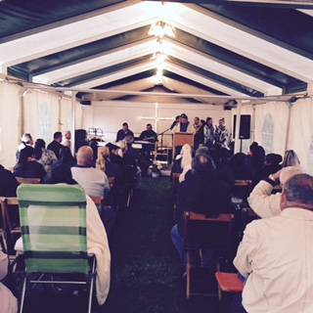
Datteln…Our Lord directed our path to Datteln for our first tent meeting. A small group of Gypsies had gathered here because a Gypsy lady, Patrin, was in the last stage of cancer. Bumba, one of the preachers from Nürnberg led the efforts to have a “small” tent meeting. A “small” tent meeting is when we have less than fifty caravans present. Everyday people drove from the surrounding areas to fill the tent at night. Two Germans out for a walk heard our music and came into the tent and were saved. Additionally, during the tent meeting two Gypsies made a profession of faith. Bumba stayed at this place all summer. He reported every month of more Gypsies getting saved.

Würzburg…We then drove to Würzburg. Bruce and the church in Würzburg organized this meeting. There are three different groups of Gypsies in Würzburg. We helped Bruce reach into each group. Seven converts were baptized at the tent meeting.
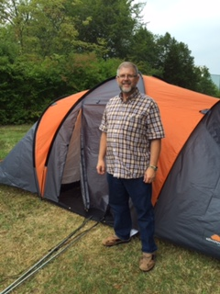
.
Bayreuth…Our newest work in Bayreuth also wanted to have a summer meeting. We moved out of our caravans into tents. This allowed even the poorest Gypsy to take part. Jim preached three times a day and Becky had a women’s meeting once a day. On the last Sunday seventeen people were baptized. One of those saved and baptized was a lady facing criminal charges. If convicted she would have gone to jail for 15 years and lost custody of her children. Between her conversion and her court date, Jasminia made many positive changes in her life. God showed grace and mercy and her sentence carried no jail time. We are still working with her so that she can have her children returned to her. None of these things could have happened without God working miracles.

Unterleiterbach…We then traveled to Unterleiterbach. Here young men from the
Bible Institute met to have another “small” tent meeting. Every afternoon we had classes for men and women. Every evening we had two evangelistic meeting. Most of the sermons in the evening were preached by lay students in the Institute. The first soul was saved the first night. Each day the blessings continued and the excitement increased.
In addition to these meetings our Gypsy preachers were spread across Germany, Austria and Switzerland. We recorded 44 baptisms of converts from our summer work. More converts are awaiting baptism!!!

Becky´s health…Becky’s blood pressure medicine is working. She is having problems with swelling in her legs. Continue to pray.

